

RESULTS AND DISCUSSION

INTRODUCTION

BLOCK DIAGRAM

*Under the guidance of,*

A.N Mukunda Rao

Associate Professor

Image Processing based Traffic Surveillance

*By:*

D K Chandrakanth 1SI20EC020

Siddharth Prabhu 1SI20EC090

Preetham G M 1SI20EC121

Mithun J B 1SI20EC124

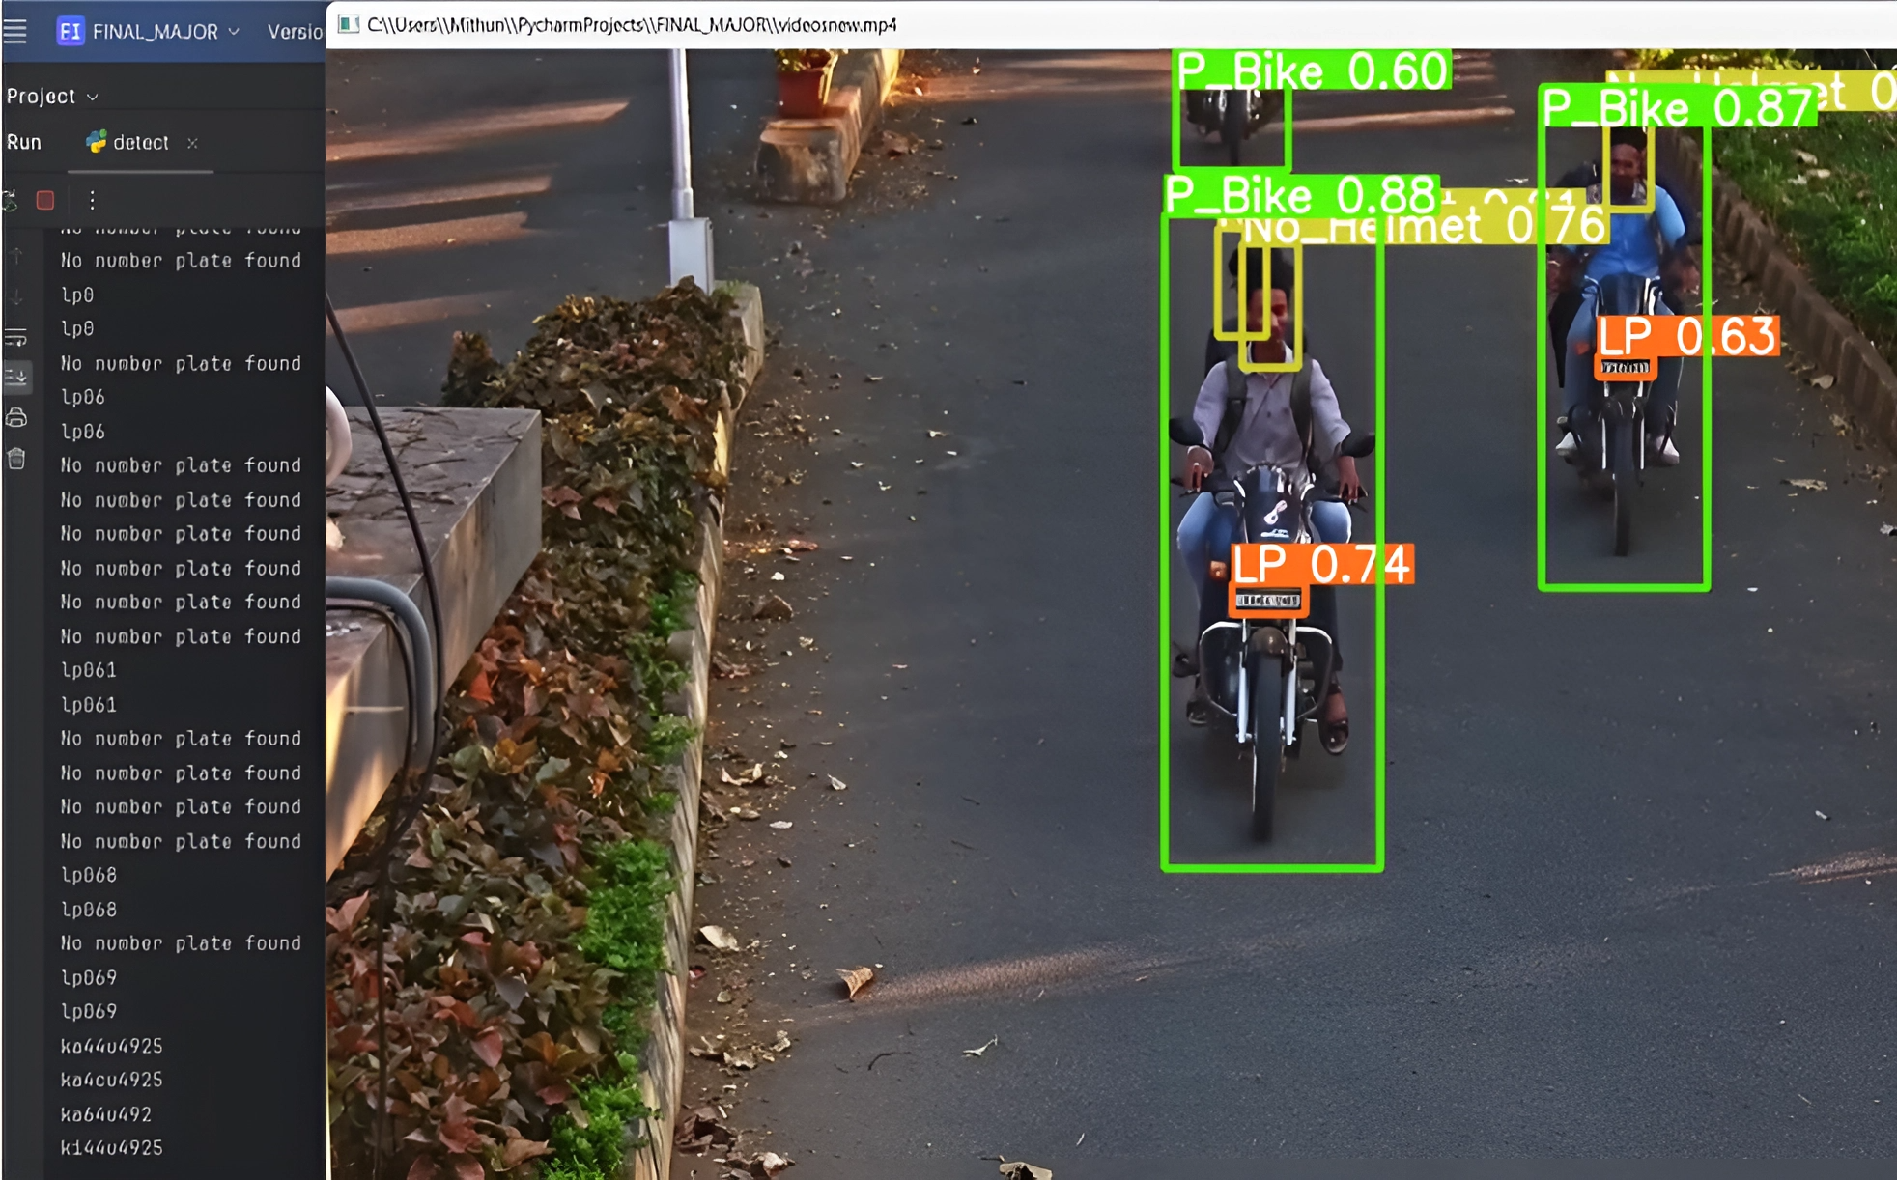

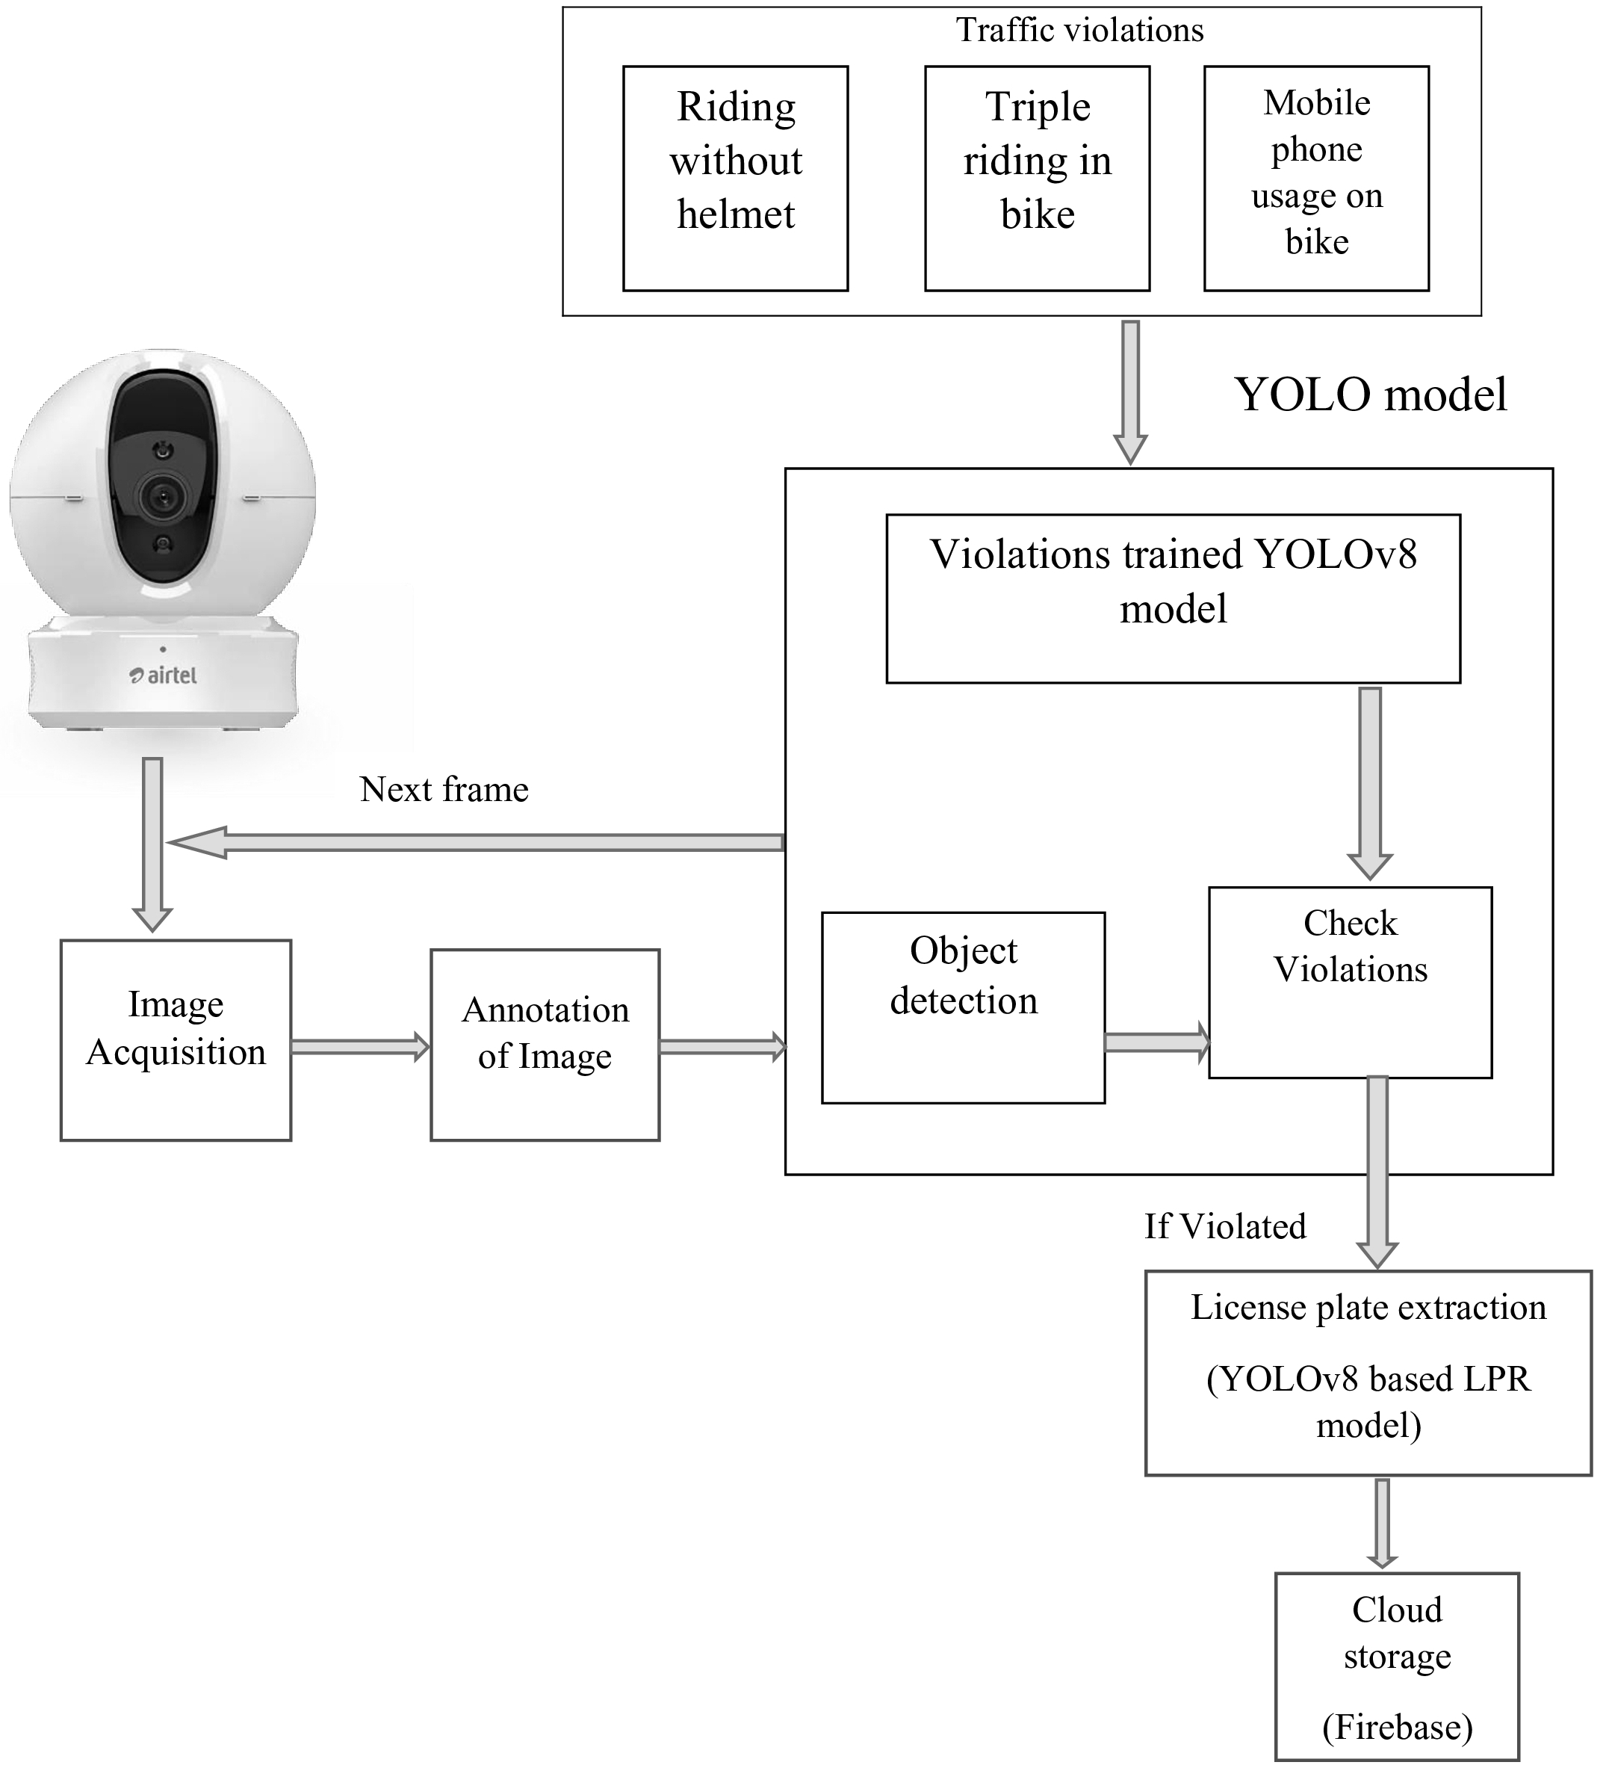

## Proposing an innovative traffic surveillance system to enhance road safety, reduce violations, and create a secure traffic environment. Integrating advanced image processing technology, the system autonomously monitors and manages various violations, such as triple riding, helmet non-compliance, and mobile phone usage. It extracts essential information, including license plate numbers and violation details, storing them securely for record-keeping. This system aims to address the rising road accidents in India by leveraging sophisticated surveillance infrastructure for real-time monitoring and automated enforcement.

OBJECTIVES

Extract the License plate information of the rule violators (two riders without Helmet & ect.)

The objective of this project is to extract the License plate information of the vehicle which violate the traffic rules such as, • Riding without Helmet

• Mobile Phone Usage While Driving.

• Triple riding while on motorcycle

The YOLOv8 model is adept at automatically detecting traffic violations such as riding without a helmet, triple riding, and mobile phone usage while riding a bike, achieving a remarkable 97% accuracy overall. With its exceptional precision in identifying helmeted riders (99%), non-helmeted riders (98%), instances of more than two riders on a bike (96%), and mobile phone usage (98%), along with recognizing license plate information with 93% accuracy, the system significantly enhances road safety through precise offender detection.

CONCLUSION

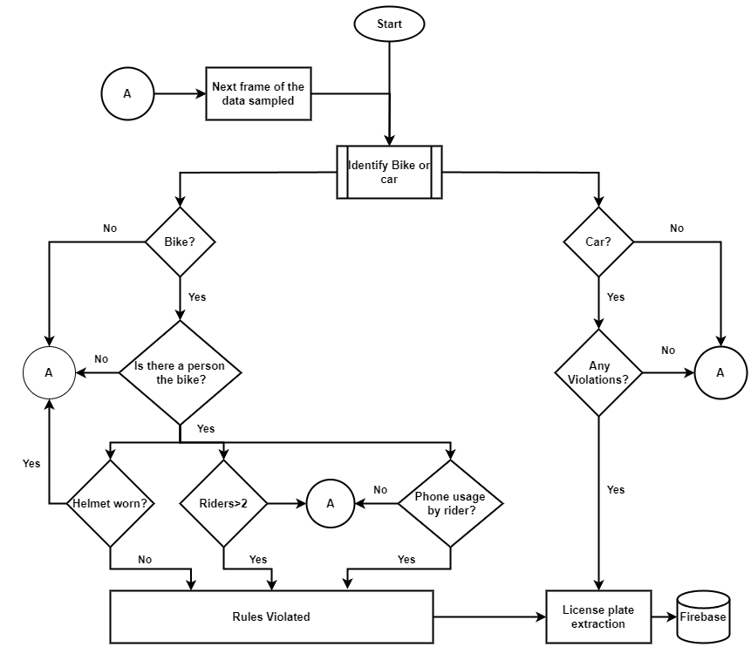

FLOWCHART

The traffic surveillance system utilizes YOLOv8 models for multiple detection tasks, including motorcycle, person, helmet, license plate, and mobile phone detection. A diverse dataset from video recordings and various channels, along with manual captures, is annotated using the YOLO format with Roboflow assistance. Training involves distinct YOLOv8 models for each task, stored on Google Drive and trained using Google Colab. Prediction employs YOLOv8 for real-time processing, predicting bounding boxes iteratively with confidence scores. Specific tasks include bike detection leading to person, helmet, license plate, and zebra crossing detection. Person detection identifies triple riding, while helmet detection captures violations and license plate numbers. Zebra crossing violation detection monitors cars and bikes, capturing infractions. License Plate Recognition (LPR) extracts license plate information, enhancing surveillance capabilities.

license plate information, enhancing surveillance capabilities.

METHODOLOGY

REFERENCES

1. H. Lin, J. D. Deng, D. Albers and F. W. Siebert, “Helmet Use Detection of Tracked Motorcycles Using CNN-Based Multi-Task Learning,” in IEEE Access, vol. 8, pp. 162073-162084, 2020.
2. A. Saumya, V. Gayathri, K. Venkateswaran, S. Kale and N. Sridhar, “Machine Learning based Surveillance System for Detection of Bike Riders without Helmet and Triple Rides,”2020 International Conference on Smart Electronics and Communication (ICOSEC), Trichy, India, 2020.